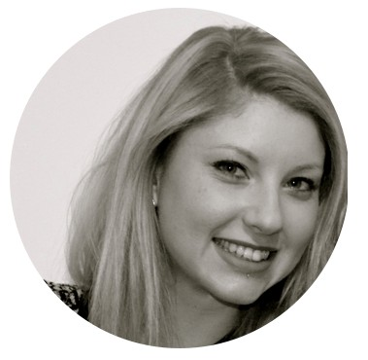
Pr
Inv

Travelling, have been in Italy, Netherlands, AT
Rou
A
Gl
Laurène Michelle Passionate woman with an education based on children product development. Interested in challenging projects, I am seeking opportunities to share and strengthen my expertise with children & licensing project management.

Let's be a part of it!

 Toys development, design & trends
 Creative
 Graphic process
 Diplomacy & negotiations
 Manage multiple projects at once
 Tight deadlines

EDUCATION

MASTER’S DEGREE & BBA
European School of Child’s Products
Management, France, 2009-2012
Key modules: child development, toy safety, generational marketing, multimedia management, licensing...
ASSOCIATE OF SCIENCES
University of Rouen, France, 2007-2009
Key modules: negotiation, marketing, communication, logistic skills...
HIGH SCHOOL DIPLOMA
Rouen, France, 2007

Holder of a French National Certificate of Aptitude In Youth Activities Organization and Entertainment.

Knowledge of Windows & Mac systems.

I LOVE

Germany, Spain, Canada, Egypt, United
Kingdom & United States.
Swedish fitness, expert.
Pencil drawing to free my mind.
Indie rock, hip hop & electronic music.
Laurenem@gmail.com - 040 145xxxxx www.about.me/xxxxx www.linkedin.com/in/laurenemichellicensing

French nationality - Fluent in English Working Visa, available to start in October Drivers licence xxxxxxxx
References on request

EXPERIENCE

THE BRAND NATION – Advertising agency

Paris, France, April 2012 – August 2014 - 2 years & 5 months
LICENSING MANAGER
Dedicated to the fast-food chain Quick, 2nd in Europe after McDonald’s. QSR market, family & child, 24 promotions/year.
2 menus: “Magic Box” for boys & girls (4-7 years old) and “Menu Top” for pre-teens
(8-11 years old), 750K to 1,5M premiums sold/month.

 Creating the collections of premiums suitable to the licensor and client from the concept to the production (reviewing consumer products categories, including toys and games, apparel and accessories).
 Ensuring the deal terms negotiated until the signature of deal memo and contracts.
 Day-to-day management of Agents & Licensors relationships such as CPLG, Hasbro, 20th Century Fox, Mattel, DreamWorks, Nickelodeon, Sony Pictures Entertainment...
 Monitoring interns who coordinated the premiums approvals, update dataset and benchmark competitive & trends…
 Working closely with the Licensing & Partnership Director for the selection of the best licensed promotion to recommend.

FERRERO FRANCE - Advertiser
en, France, 2011 – 6 months – internship
SSISTANT PRODUCT MANAGER
obal confectionery manufacturer (Nutella, Tic Tac, Kinder Surprise...)

 Participating in the brand strategy development & the launching of new TV commercial of the brand Nutella (benchmarked, monitored the qualitative studies…).
 Making monthly analysis of the sales (Nielsen & Kantar Worldpanel).  Involving in projects to renew the graphic identity design on packaging.

CUISINE SANTE INTERNATIONAL
Ottawa, Canada, 2010 – 3 months – internship
SALES REPRESENTATIVE
Exclusive seller of cookware of the brand Berghoff.
Attending shows, telemarketing, negotiation B to C in English.

ELIS
Rouen, France, 2009 – 12 months - work-study contract
SALES REPRESENTATIVE
European leader in rental - maintenance of services for groups and SME’s. ospecting (services: water fountains, coffee machines and mats).
olving in setting up of reporting commercial tools.

ELIER GILLES DRU
Rouen, France, 2008 – 12 months - work-study contract
SALES REPRESENTATIVE
Business specialized in digital printing for SME’s and local shops. Prospecting SME’s and micro businesses, from quotes, computer graphics brief to pre production sample.

